**Vincent ROMANET** Courdimanche, June 20th, 2018

22 rue des Perdrix

95800 Courdimanche

FRANCE

+33(0)6.66.57.91.97

[romanetvin@eisti.eu](mailto:romanetvin@eisti.eu)

Object : Spontaneous application for an apprenticeship in Artificial Intelligence

Dear Mrs, Mr,

Currently following a double diploma at Grenoble Ecole de Management (GEM), I will end my scholarship next September at my school , the Ecole Internationale des Sciences du Traitement de l’Information (EISTI) in Computer Engineering in Cergy, France. During my third and last year at the EISTI, I plan to specialize myself in Artificial Intelligence. I am a 23-year-old French student.

Within the framework of my scholarship, I wish to do an apprenticeship in Artificial Intelligence starting in September 2018 in the energy industry.

Having an open mind and being a man of conviction led me to Canada for a volunteering experience in a nature conservation association and later to Singapore for a student exchange. I deepened my knowledge about management as I took courses at GEM for a double diploma. I am rigorous in my work and respect very much punctuality. I have a good level in English that I try to improve by watching English series without subtitles and also speak Chinese because of my mother. I played volleyball and basketball in High School which helped me with team work. I also have knowledge in Scala and Python which I consider very useful and practical for working on Machine Learning and Deep Learning. During my specialization courses, I will attend several AI courses such as Deep Learning, Natural Language Processing and AI Ethics. Working for Voltalia would be for me an excellent learning experience to strengthen my future prospects and for you to profit from the perspective of an aspiring-to-become computer science engineer in the energy industry.

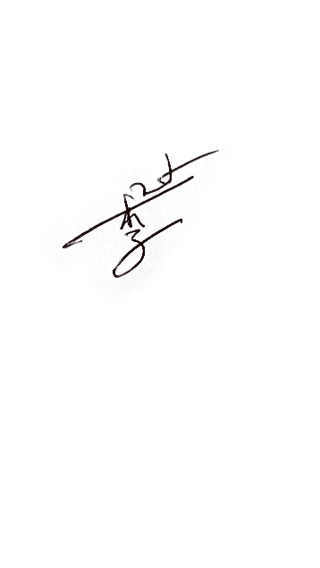 I would appreciate hearing from you; I can be reached at [romanetvin@eisti.eu](mailto:romanetvin@eisti.eu) to provide any additional information you might require. Enclosed you will find my résumé. Thank you for your consideration.

Yours sincerely,

Vincent ROMANET